**Macroeconomic aspects of unemployment insurance: evaluating the Danish policy**

**Abstract**

This paper provides a macroeconomic assessment of the Danish public policy of reducing unemployment benefits, voted by the Danish government in the tax reform of 2012. We do so by estimating the macro elasticity of income insurance on unemployment. We find it important to analyze the full macroeconomic effects as the Danish income insurance model, used by the Danish government to analyze changes to the Danish income insurance program today, do not include any macroeconomic effects. To obtain these macro effects we utilize the quarterly Stock-Flow-Consistent model for the Danish economy. Here we incorporate the Danish income insurance program and five macroeconomic channels, allowing changes in the program to affect the economy. We simulate the model including these five channels to generate an estimate of the change in unemployment associated with each macroeconomic effect both independently and together. We then use these macroeconomic effects together with the microeconomic effects found by the Danish income insurance model to estimate the macro elasticity. We find the macro elasticity to be approximately twice as large as the micro elasticity in the case of Denmark. Using a Baily-Chetty framework including the macro elasticity obtained in this paper, we find evidence that suppressing the state regulation percentage in Denmark was a correct decision looking at the economic welfare. More interestingly, we find this conclusion to be highly dependent on two findings. First, whether the Danish economy is categorized as wage-led or profit-led. Second, the willingness of the worker unions to maintain a high incentive to work, by maintaining a minimum-gap between the level of income insurance and wages. The results of this paper questions the way in which only microeconomic effects so far has been considered when evaluating political decisions regarding the Danish income insurance program.

**Keywords:** Unemployment Benefits, Stock-Flow Consistent Models, Denmark

**JEL-codes:** E12, E25, E57, E01

# **Introduction**

The Danish labour market, also known as the flexicurity model, is widely recognised for keeping a low and stable unemployment rate, compared to other countries. Three core features characterise the flexicurity model, as highlighted by Andersen and Svarer (2006): i) flexibility in hiring and laying off workers, ii) income security in the form of generous unemployment benefits, and iii) an active labour market policy. These three features combined, makes the labour market well-functioning: the flexibility in hiring and laying-off workers ensures that Danish employers can quickly adjust their workforce according to their needs; the labour unions allow lax hiring and laying-off conditions due to high income security for unemployed workers; the active labour market policy ensures that laid-off workers, while searching for a job, take active part in activities that can improve their skills and knowledge.

Despite the success of flexicurity model, the public policy in relation to unemployment insurance has shifted over the last decade or so. The Danish government, as part of the 2012 tax reform, decided to lower unemployment benefits for the period of 2016-2023, with the aim of increasing economic growth and employment, while reducing pressure on the public expenditures. To formally evaluate the policy prior to its implementation, the Danish income insurance model (IS-model) was developed in 2015: the results of the model - broadly in line with the existing literature (Andersen et al. 2015) - favoured the policy of lowering the level of income insurance, specifically, finding that lowering unemployment insurance can considerably increase the exit-rate from unemployment. The model findings were subject to criticism from worker unions and unemployment insurance companies, arguing that the estimates (based on purely micro aspects) were unreliable and that important macroeconomic channels, amongst several other aspects, were absent in the evaluation (Aastrup, 2018; Jensen & Nørgaard, 2021; Risgaard, 2021).

The aim of this paper is to introduce relevant macroeconomic channels in the assessment of unemployment insurance policy while evaluating the Danish tax reform of 2012 as a case study. In particular, the paper explores how, if at all, macroeconomic channels can influence the potential effects of unemployment insurance policy? Earlier literature on unemployment insurance policy heavily draws on microeconomic aspects, finding that lowering unemployment insurance in most cases can increase the exit-rate from unemployment (Holmlund ([1998](javascript:;));(Carling et al., 2001);(Røed & Zhang, 2005);(Card et al., 2015); Andersen et al. 2015;!). This strand of the literature has greatly influenced the features of the Danish income insurance model, the findings of which are used by the policy makers to justify the changes in unemployment insurance in Denmark. The literature focusing on aggregate (or macro) aspects when analysing unemployment insurance policy is relatively recent, and the number of studies in this area are limited without any clear conclusion (Albertini and Poirier (2015); Zhang (2017); Chodorow-Reich, Coglianese, and Karabarbounis (2019); Fredriksson and Söderström (2020); Boone et al. (2021)). Our paper contributes to the more recent literature by taking into account the aggregate effects of unemployment insurance while recognising the relationship between the micro and macro effects.

Although there are many ways to address the macro aspects of unemployment insurance policy, we adopt a comprehensive modelling strategy and build a structural economic model, following the stock-flow consistent (SFC) approach of Godley and Lavoie (2006). Our proposed framework , inspired by the Post-Keynesian theory, incorporates many of the holistic modelling capabilities of other economic approaches: it enables us to analyse the interaction of different sectors and understand the complex feedback effects while explicitly modelling the interdependencies between the real and financial side of the economy, which otherwise is beyond the scope of many existing studies on this topic. While considering various macroeconomic channels, we integrate the features of the Danish income insurance program in our framework, specifically, including the policy variables that are targeted by the policy makers to lower unemployment insurance. While UI policy has been addressed in the stock-flow consistent framework by Byrialsen and Raza (2018), our paper is the first one to evaluate UI policy in a full-fledged empirical stock flow consistent model. We validate our model by performing simulations on quarterly Danish data, finding that our model is able to capture the overall dynamics of the Danish economy. To evaluate the effects of unemployment insurance policy, we perform a counterfactual analysis by reversing the public policy in relation to unemployment insurance implemented in 2016 and compare the results with the baseline containing the policy effects. We find that reversing the public policy can both increase or decrease unemployment through macroeconomic channels, the defining elements being the strength of the workers unions and the demand regime of Denmark.

The remainder of the paper is organized as follows:

# **Relevant Literature**

One of the most recurring research questions in the economics of unemployment insurance concerns the effects of increases in the levels and durations of unemployment insurance on employment. Earlier theoretical literature based on standard search theory narrowly focused on the effects of unemployment insurance policy on an individual’s incentive to work and job-searching behaviour (Mortensen, 1977; 1990; other recent papers?). This theory predicts that reducing the level and duration of unemployment insurance will reduce unemployment spells. The empirical literature at large supports the theoretical prediction, but controversy remains regarding the magnitude of the effect as repeatedly highlighted by studies over the years (Holmlund (1998); Krueger and Meyer (2002); cite: Unemployment duration and unemployment insurance: a comparative analysis based on Scandinavian micro data; more recent papers?). The theoretical literature on standard search theory later advanced into the theory of search and matching frictions, focusing on equilibrium unemployment (Diamond (1981), Mortensen (1982) and Pissarides (1984), Shapiro and Stiglitz (1984)). Some of the key features of this theory are the inclusion of a wage bargaining process and firms’ decision of hiring workers; it argues that increasing unemployment insurance leads workers to demand higher wages, to which employers will respond by hiring less number of workers. Thus, introducing the effects of unemployment insurance in a flexible wage-setting can magnify the adverse effects of generous unemployment insurance policy. To sum-up, the theory of search and matching friction in its most typical version predicts that an increase in unemployment insurance will not only increase unemployment spells, but will also increase the probability of layoffs (citation: Unemployment Compensation and Labour Market Transitions: A Critical Review).

The search and matching theory associated with Diamond, Mortensen and Pissarides (DMP), has also played a key role in the macroeconomic analysis of unemployment insurance policy (citations). The results of most macroeconomic models with micro foundations broadly support the DMP prediction, however, controversy again remains regarding the magnitude of the effect, which in turn depends on other key assumptions of the model. The macro effects of UI can be larger or smaller than the micro effects, depending on the assumption of other variables such as, wage adjustment, labour participation rate, and productivity citation: (e.g., see the discussion on micro vs macro effects in Unemployment Insurance and the Labor Market∗ Josef Zweimuller) – In which cases, the macro effects can be larger or smaller than the micro effects should be explain in detail here! On the empirical front, the scarce literature on macro effects of UI has reported mixed results. Empirical studies in this regard can be broadly classified into two categories based on their approach.

***Direct macro estimates:*** studies in this category use various empirical techniques to get a direct measure of the macroeconomic elasticities associated with the unemployment insurance. For example, Fredriksson and Söderström (2020) investigate the aggregate effects of a reform in Sweden, finding that a 1 percent increase in income insurance ceiling increases the number of unemployed by 3 percent. The implied macro elasticity is found to be twice as large as the corresponding micro elasticity in their study. Boone et al. (2021) on the other hand, finds that the aggregated effects are almost zero when looking at the expansion of the UI program duration during the Great Recession in the US economy.

***Structural macro estimates:*** studies in this category use a structural economic or econometric model to analyse the effects of unemployment insurance while explicitly modeling the relevant transmission channels. For example, the results of the macroeconomic model by (Albertini and Poirier (2015) show that an increase in unemployment benefits at zero lower bound reduces unemployment whereas it increases unemployment in normal times. The authors find that the underlying feedback effects from inflation and wages are crucial in the assessment of unemployment insurance. Zhang (2017) estimates a DSGE model for the US finding that unemployment benefits shocks increase unemployment. Regarding the magnitude of the effect, the author concludes that unemployment benefits shocks in the long run can explain a large proportion (over 27 percent) of fluctuation in unemployment.

Both these empirical approaches have their own pros and cons. For example, the direct estimations usually benefit from the large micro datasets, but the results are silent about the transmission mechanism and the various feedback effects. On the other hand, studies using a structural approach are explicit about the transmission channel but the results to some extent depend on the assumptions about the channels and the type of feedback effects included in the assessment. Thus, it can be argued that the results of each approach should be taken with caution and that both approaches should be considered before drawing conclusions.

**2.1 The Danish Income Insurance model**

The Danish income insurance model (citation) is the workhorse of Danish policy makers to evaluate the effects of changes to income insurance. The majority of the empirical evidence used to justify the model structure comes from the literature review carried out by Andersen et al (2015). While investigating the effect of an increase in the level of income insurance, the authors review 28 studies, all finding that UI negatively affects the exit rate from unemployment (24 of the studies conclude a significant negative effect whereas 4 studies conclude insignificant negative effects). Andersen et al. (2015) also reviews three studies looking at the effects of unemployment insurance on layoffs: Topel (1983), using American retrospective data from 1975, finds a significant effect whereas the more recent studies by Jurajda (2002) and Falch (2015) find no significant effects.

**2.1.1 Key features and findings of the Danish Income Insurance model**

The Danish Income Insurance model framework has four main components: i) A static model for income insurance, a static model for Cash-benefits[1], a Markov-model, and lastly a re-earning model.[2] The static model of income insurance is developed to calculate the immediate economic effects for a specific person being unemployed when changing the level of income insurance. The Markov-model is built to calculate the equilibrium levels of employment and unemployment. The population is divided into three groups, i) receivers of income insurance, ii) employed, and iii) receivers of other social benefits. The Markov-model estimates the probability of changing in-between these three groups. The model is estimated using the 2010 reform suggesting that the policy of UI tightening in the form cutting the duration of benefits considerably reduces the exit rate from unemployment (Dagpengekommissionens sekretariat, 2015). These behavioural effects are specified as elasticities, meaning that a relative change in the exit rate from unemployment to employment is a function of the relative change in the level of income insurance.

The model estimates are subject to criticism by a number of studies. Jensen (2021), Risgaard (2021) and DØRS (2022) argue that IS-model is overstating the adverse effects of income insurance by including the effects of unemployment insurance on layoff rates, for which there is no convincing empirical evidence. Aastrup (2018) argue that a large percentage of the group experiencing the highest level of compensation rate are still in job, thereby rejecting the explanation that UI generosity can pull employed into unemployment. (Here we should conclude the discussion by citing the criticism on the missing macro effects, which authors are those?)

# **Understanding the Danish unemployment insurance program**

The level of unemployment benefits in Denmark is partly determined by wage developments and partly by a government-imposed cap on these benefits. A person who is unemployed is entitled to 90 percent of his previous earnings, provided that this amount does not exceed the state's maximum benefit cap. If a person's unemployment benefits reach the maximum level at a lower percentage of his prior earnings than 90, he is only eligible for the maximum level of UI rather than the full 90 percent of the previous earnings. It is worth noting at this point that the vast majority of unemployed Danes (approximately 85 percent) receive the maximum level of UI. The policy makers have repeatedly tightened unemployment insurance by focusing on the maximum level of UI.

To understand how the maximum level of UI is determined, it is helpful to consider the equation of the growth rate of the maximum level of UI as follows:

eq. 1

The growth rate of UI represented by is determined by an *exogenous policy growth rate* and an annual *adjustment rate*, which in turn depends on the growth rate of wages ( two years prior to the current financial year.

The annual adjustment rate represented by () is thus calculated as the growth rate in past wages subtracted by 0.2 percent. One can think of as some sort of a long-run growth rate set by the policy makers whereas can be seen as the component of maximum UI that follows the labour market conditions.

It is important to highlight that the adjustment rateis not allowed to have symmetric effects on maximum UI. That is, if in a given year results in a growth rate below zero, it will lower the growth rate of maximum UI as shown in equation 1. If results in a growth rate between 0 and 0.3 percent, no annual adjustments are implemented, and maximum UI will grow at a rate of . If results in a growth rate higher than 0.3 percent, then a further 0.3 percent is subtracted from the outcome and the implemented annual adjustment rate in equation 1 takes the form of .

**3.1 Public policy of UI tightening**

Since the Great Financial Crisis (GFC) of 2008, policymakers in Denmark have made a number of attempts to tighten UI. The government reduced the duration of UI from four to two years in 2010. A number of economic reforms were put into place in 2012 with the intention of promoting employment and growth without weaking the structural budget balance. As part of these reforms, public policy on unemployment insurance was tightened by targeting the maximum level of income insurance. The prevalent exogenous growth rate of in equation 1 was 2 percent; the government decided to reduce the growth rate of by 0.3 percent points in 2016, 0.4 percent points in 2017, and 0.75 percent points from 2018 to 2023.

The Danish UI framework ensures that the maximum level of income insurance does not increase at the same rate as wage increases, which has led to a persistent decline in income insurance relative to wages. Figure 1 shows that the compensation rate, measuring the income insurance relative to the wage, has been falling since the 1990s.

Figure 1: The compensation rate 1990-2018

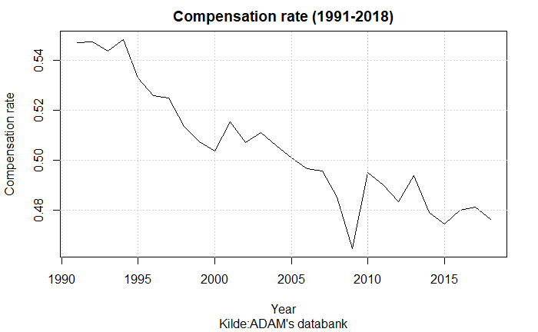

# **4. Macro effects of UI in a stock-flow consistent model**

To explore the macroeconomic effects of UI policy, we employ a stock-flow consistent model. Our model is predominantly post-Keynesian, with demand determining the level of economic activity and credit. The model consists of 5 institutional sectors (households, production sector, financial corporations, government, and the rest of the world); 5 financial assets (deposits, loans, bonds, equities, and insurance & pensions); and 2 fixed assets (machinery & equipment, and buildings & dwellings). The main equations of the model in relation to public policy on UI are presented in the section that follows. In the description of the model, small letters represent real quantities and capital letters represent nominal quantities, unless otherwise specified.

We treat Denmark as a small open economy with a fixed exchange rate. We assume that all goods and services in the economy are produced by the production sector. The aggregate demand identity is represented by equation 2:

eq. 2

where *c* represents real consumption, *i* represents investment, *g* represents government consumption, *x* represents exports, and *m* represents imports.

The number of individuals employed *(N)* in the economy is determined by real output *(y)* to labour productivity (*a*) as follows:

eq. 3

The labour force is determined by the participation rate *(part)* and size of the population *(pop):*

The level of unemployment *(UN)* is defined as the difference between the labour force *(LF)* and the number of people employed *(N):*

4.1 **Household income and consumption**

Focusing on the income insurance system, the level of unemployment benefits in Denmark is linked to the development of the wages in the economy. In the following we established the link between unemployment benefits and the rate of income for unemployed as well as the wage rate for workers.

As previously stated, UI at an individual level is set to 90 percent of the previous wage earnings. As a result, the amount of UI an individual is entitled to rises in tandem with his wage until it reaches the maximum level of income insurance () set by the government.

The maximum level of UI can be estimated within the model following the approach of the Ministry of Finance.[3] For that purpose, we simply convert equation 2 from growth rates to levels of maximum UI:

Where we calculate by using the annual wage growth two years before the financial year. As previously stated, if () results in a growth rate less than zero, the adjustment rate is negative, and the maximum level of UI will evolve as described in equation 6. If () yields a growth rate between 0 and 0.3 percent, no annual adjustments are made, and the maximum level of UI increases at a growth rate of If () produces a growth rate greater than 0.3 percent, another 0.3 percent is subtracted from the result, and the implemented annual adjustment rate in equation 1 becomes .

We now look at how changes in maximum level of income insurance affects average individual income insurance. To establish a general relationship in this regard, we use data on the *average* level of income insurance per individual (), which is calculated by finding the cross-sectional mean of all unemployed people over a specific time period. We then regress (on the *average* level of income per individual () across time, finding the coefficient to be 0.95.

The estimated coefficient states that a unit increase in maximum level of income insurance corresponds to a 0.95 unit increase in the average income insurance per individual. This would have been the case if 95 percent of unemployed people received the maximum level of UI, but data from ADAM suggest that only 85 percent do. The upward bias in our estimate could be due to an endogeneity problem caused by omitting wages. We take these issues into consideration and later on lower the estimate from 0.95 to 0.85.

NOTE: Hamid has read and edited the paper until this point!

The compensation rate can now be calculated as the fraction of average income insurance of to the average wage received by a worker ().

Next, to create a relationship between the compensation rate and people’s choice in joining the insurance program[4], we assumed, that people compare membership costs to the generosity of the program, so a lower compensation rate causes more people to leave the program (Aastrup, 2018; Jensen & Nørgaard, 2021; Risgaard, 2021). The insurance rate[5] can therefore be expressed as a function of the rate of compensation.

In contrast to Byrialsen et al. (2022), we are therefore able to model the total amount paid in income insurance to the households , which is calculated as the *average* level of income per individual () multiplied by the number of insurance unemployed,

Together with all other benefits received by households, , feeds into the disposable income through the component of current transfers ().

According to the literature presented in section 2, wages might also be affected by the level of unemployment benefits, by playing an important role in the determination of the targeted wage. We determine wages as follows within the model.

We assume that the labor unions have two main targets when determining the target wage.

First, they want the wage to follow inflation so that workers keep their purchasing power over time. Second, they set a threshold for the minimum wage gap the unions are ready to accept[6], measuring the difference between the wages and maximum level of income insurance relative to the wages, to maintain a certain incentive to stay employed.

In cases where inflation itself is not establishing the minimum wage-gap alone, the unions set the targeted wage so that the wage gap is achieved. The equations for the target wage and the wage gap can be seen below:

Since both the income for employed as well as unemployed has been modelled, we can proceed to discussing the consumption decision of the household.

We have now established the link between unemployment benefits and the rate of income for unemployed as well as the wage rate for workers, which allows us to move towards focusing on the decision to consume among the households. Our approach differentiate itself from most empirical models, by dividing disposable income in two components ( consists of wage income and social transfers and consists of profits and income of property) with different propensities to consume.

We find cointegration between the real consumption and both real disposable income and real financial wealth. Therefore, the consumption function is estimated using an error correction model, taking the following form:

Asides from affecting household consumption, changes in disposable income also affects household investment in dwellings.

4.2 **The rest of the economy**

Changes in household consumption (and household investment) affects aggregate demand, which affects other demand component via standard Keynesian mechanism: import is affected by domestic demand and real exchange rate, export is affected via foreign demand (which is determined exogenously) and real exchange rate. Since the level of investment by firms follows a standard multiplier approach, investment would react pro-cyclical to changes in the level of aggregate demand[7]. Finally, both government consumption and investment are assumed to be exogenous, these are not affected by changes in the economic activity.

While neither public consumption nor public investment is endogenous, the public balance is still affected due to the automatic stabilizers in the model. On the income side, the tax revenue of the government will be affected by the changes in economic activity, due to changes in the level of employment. On the expenditure side, the number of unemployed, who receive unemployment benefits is also affected by the economic activity. We assume for simplicity, that the government finances the entire Income insurance system, which is not the case in reality. The effect of a change in the level of income insurance will therefore overshoot the effect on government net lending[8].

## 4.3 **Validation of the model**

In this section we look at the performance of the model, comparing the simulation results of the baseline model with actual data. In the figures below we compare the simulated and actual data for GDP, Employment, wages and maximum level of income insurance.

Figure 2: Simulation vs. real data.

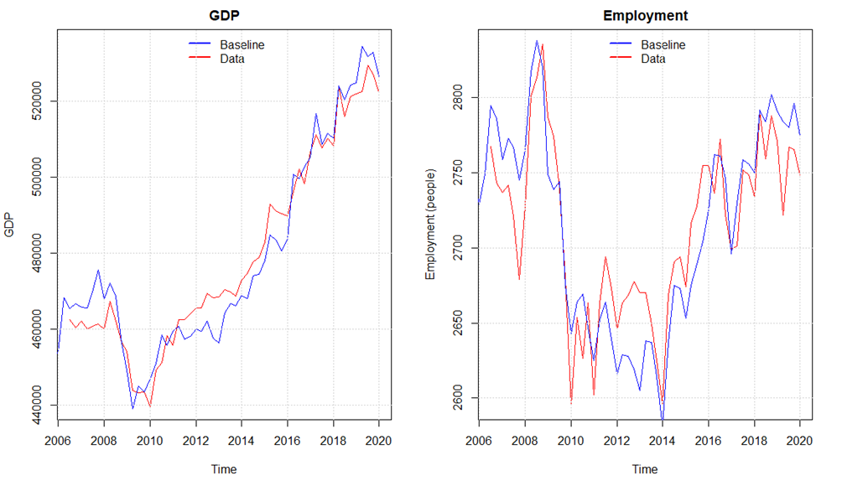

Overall, the model seems to capture the medium to long-run tendency of GDP and employment as seen in figure 3, even though there are some divergences in some quarters. However, a small overshooting, due to higher simulated value of real investment and consumption, can be identified for both variables in the period 2011 – 2016.

This overshooting of economic activity also results in a higher level of the maximum level of income insurance in some periods as seen in the right part of Figure 4. Finally, the model seems to be able to catch the overall development in wages for the whole period.

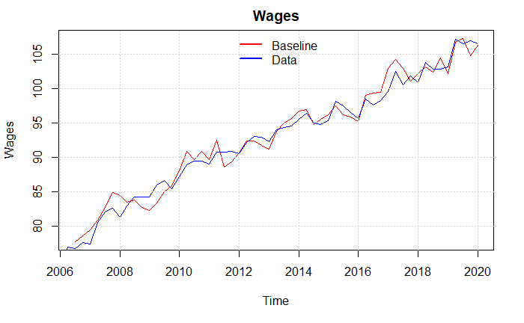

Figure 3: Simulation vs. real data

# 5 **Result and Discussion**

We now introduce three scenarios, where we are removing the suppressing of the state regulation percentage starting from 2016Q1 under different settings, in order to investigate the effects of changing the level of unemployment benefits. In the first scenario we remove the suppressing of the state regulation percentage starting from 2016Q1. In the second scenario, we perform the same shock as in scenario 1, but at the same time, we are weakening link between unemployment benefits and labour force. The motivation for this scenario can be found in recent work by the Danish reform-commission, which claim that the group of people outside the labour force is unaffected by labour market reforms (Smith 2021). In the third scenario, we add another element to scenario 2, by removing the link between unemployment benefits and wage setting. The motivation for this is the drop in compensation rate illustrated in Figure 1, which might reduce the incentive to have a strong effect of changes in unemployment benefits on wages. Finally, in the last part of this section, we use the model to create input to evaluate the regulation policy from the perspective of the Baily-Chetty formula.

## 5.1 **Scenario 1: Removing the suppressing the state regulation percentage.**

In this first Scenario, we perform a counter factual shock in removing the suppressing of the state regulation percentage. The state regulation percentage is usually fixed at 2%, but due to the tax reform of 2012, the regulation percentage should be subtracted by 0.3 percent points in 2016, 0.4 percent points in 2017, and 0.75 percent points in 2018-2020.   
To perform the shock, we keep the percentage fixed at 2% for the entire period after 2016.

In the Figure 4 below, we find that in this scenario, removing the reduction in the level of unemployment benefits affects the economy positively in the very short run. This effect can be explained by the fact, that an increase in the level of unemployment benefits creates an increase in the income of households, which affect the economic activity positively. After the first quarter however, the effect turns negative relative to the baseline. This negative effect on GDP can be explained by several channels. Firstly, the increase in the maximum level of benefits relative to the baseline level reduces the gap between the maximum level of benefits and wages below the threshold. The effect of this is, that the targeted wage will be adopted with the purpose of remaining the gap at the threshold. As the targeted wage increase, so does the wages and prices, which has a positive effect on consumption, but a negative effect on the level of competitiveness, which reduces the net export. Finally, the increase in wages lead to an increase in the wage share (and reduction in profit share), which, together with the fall in economic activity, has a negative effect on investment. Secondly, the lower economic activity reduces the level of employment, which increases the level of unemployment as well as the rate of unemployment. The increase in the rate of unemployment reduces the participation rate and thereby the size of the labour force. Since the reduction in the labour force is smaller than the reduction in the level of employment, we see an increase in the level of unemployment of around 200 people 2 years after the shock and around 500 people four years after the shock. Following Post-Keynesian literature, this result indicate that the Danish economy can be characterized as being profit-led, since a labour-oriented distribution policy leads to a fall in the economic activity.

## 5.2 **Scenario 2 Denmark as a mature economy**

As argued by Smith (2021), these types of reforms aimed at changing the incentives for people to participate in the labor force by reducing the benefits, seems to have almost no effect, since those who would be affected by these reforms are already part of the labor-force. Furthermore, the rate of unemployment in Denmark is so low, that lowering it even further might not have the same effect on the decision to join the labour force as expected with higher rates of unemployment. To investigate this, we perform scenario 1 again, but this time we assume the labour force to be exogenous.[9]

Again, we see a positive effect of removing the reduction in the level of unemployment benefits in the very short run, due to the higher income among the households. In the short to medium run, the result of scenario 2, follows the same dynamic explained in scenario 1 with only minor differences. Since the labour force is unaffected in this scenario a reduction in the level of employment lead to a one-to-one increase in the level of unemployment. As seen from Figure 4, the level of unemployed increases with around 250 people after two years and around 700 people after four years. The same conclusion can be found when focusing on the effect on GDP, as seen in Figure 5. As explained above, the reduction in the level of employment results in a one-to-one increase in the level of unemployment (and rate of unemployment), which reduces the increase in wages and prices compared to scenario 1, which reduces the negative effect on both net export and investment compared to scenario 1. Despite the minor differences between the two scenarios, the overall result of a negative effect of this scenario on both the level of unemployment and the economic activity still holds.

## 5.3 Scenario 3 Removing the effect on wage negotiations.

In the last scenario we run scenario 2 again, but this time we further assume, that changes in the maximum level of benefits no longer affects the targeted wage set by worker unions.

As seen from Figure 4 and Figure 5, the effects of a change in unemployment benefits seems to be depended on whether wages are affected or not. Removing the effect on the targeted wage change the overall effect of a change in the level of benefits, since it in contrast to scenario 1 and 2 reduces the number of unemployed. The number of unemployed is reduced with 100 people over 2 years and 300 people over 4 years, which is explained by the increase in economic activity. This increase in the economy in the very short run is, like in the previous scenarios, explained by an increase in the part of household coming from social transfers. Unlike the situation in scenario 1 and 2, no crowding out effect on wages and prices can be found directly as a result of higher level of benefits. Instead, the higher economic activity leads to higher level of employment, which with a fixed labour force, result in a one-to-one reduction in the level of unemployment. The lower rate of unemployment affects wages positively, which combined with higher level of employment result in an increase in the wage bill of the households. This leads to an increase in household consumption (and investment), which exceeds the fall in investment and net export. To use the terminology introduced earlier, the Danish economy has changed from profit-led in scenario 1 and 2, to being wage-led in this scenario.

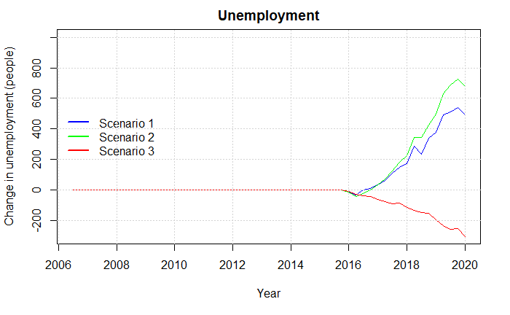

Figure 4: Effect on unemployment in Scenario 1, 2 and 3.

Finally, except from the effects on the level of unemployment and economic activity, another political argument for introducing the tax reform in 2012, was an improvement of the public balance. Figure 5 illustrates the effect on the public balance in the three scenarios.[10] At first glance, the result might seem surprisingly. Except from the expenditures related to higher benefits per unemployed, the main effect on the public balance in this model is due to the automatic stabilizers. Since the economic activity only increases very little in the very short run in all three scenarios, the higher level of expenditure per unemployed exceeds the positive effect from higher tax income (and fewer unemployed). In the short- to medium-term, the effect on the public balance diverges among the three scenarios. In scenario 1 and 2, the increase in the level of unemployment benefits results in an increase in wages, which, despite the fall in employment, has a positive effect on the tax revenue of the government. This increase in tax income of the government, exceeds the increase in the unemployment benefits despite an increase in the level of unemployment, which establish an overall positive effect on the public balance. After 4 years however, the effect turns negative in both scenarios, which is explained by the fact, that the effect on wages disappears as the gap between the level of maximum benefits and wage widens. The effect of this, is a reduction in the wages and therefore the tax revenue. In scenario 3 on the other hand, the effect on the public balance is negative both in the short and medium run. In this scenario, the increase in the benefits doesn’t affect the wages directly. This combined with the relatively small effect on the economic activity, leads to a reduction in the government savings, while the level of investment is unaffected by the shock.

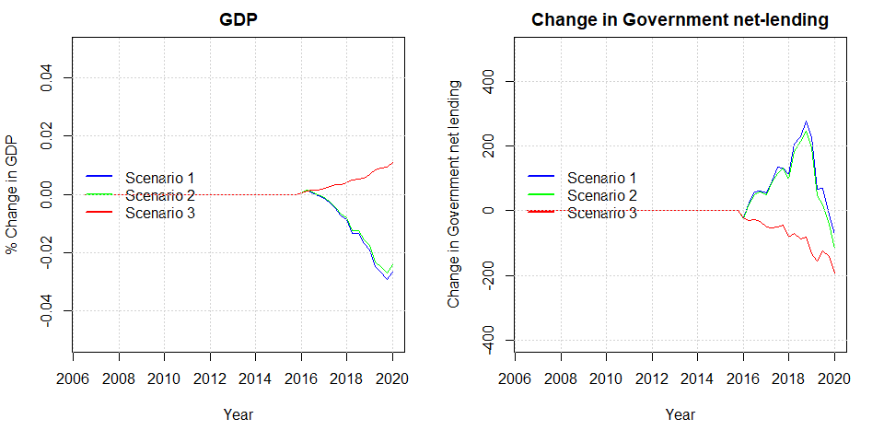

Figure 5: Effect on GDP and Government net lending in scenario 1, 2 and 3

## **5.4 Evaluating regulations towards the Danish income insurance program**

As seen from the results above, the overall effect is highly depended on the settings, under which the shock is carried out. For this reason we will discuss the different conclusions obtained when using the different scenarios found in section 4, to calculate the macro elastic, in order to qualify the discussion of the reform.

As presented in section 2, the literature regarding income insurance is moving more towards estimating the full macro elasticity, instead of the often-used micro elasticity found by the Danish income insurance model. Fredriksson & Söderström (2020) concludes that when not knowing the macro elasticity relative to the micro elasticity of income insurance, it is not possible to make the right political decisions. If the macro elasticity equals the micro elasticity, then the Baily-Chetty formula applies directly (Baily, 1978; Chetty, 2006). If the macro elasticity is greater than the micro elasticity, and there are aggregate inefficiencies, then income insurance should be set lower than the level dictated by the Baily-Chetty formula. A key question is thus whether the macro elasticity is greater/lower or equal to the micro elasticity. (Fredriksson & Söderström, 2020)

To calculate the macro elasticity for Denmark, we use the same idea as Lalive et al. (2015) where calculating the macro elasticity implies taking the sum of the micro effects and macro effects. So, if finding significant macro effects, as we do in our study, we can use those together with the micro effects of the IS-model to obtain an estimate of the macro elasticity[11].

We estimate the micro elasticity for the Danish economy using calculations presented by the ministry of labor, using the IS-model to provide the effects of removing the suppressing of the state regulation percentage in the period 2020-2023[12]. They estimate that removing this regulation will leave the level of income insurance to increase by 2.25%, and thereby lower employment by 2900 people[13]. This is further split up showing the effect associated with the exit-rate (1600 people) and the approach-rate (1300 people) independently (Hummelgaard, 2021). As mentioned by Jensen (2021) the approach rate in this example contributes with 45% of the total effect, which they find to be very unrealistic.

When estimating the micro elasticity, we therefore include different measures of the approach effect in our analysis. Besides following the estimates of the IS-model (where the approach rate contributes with 45%), we also include the results found by DØRS (2022) who argues that the estimate used in the IS-model is twice as large compared to what newer literature suggests. Additionally, we will include the case in which the approach effect is not present at all as argued by literature presented in section 2 (Aastrup, 2018; Jensen & Nørgaard, 2021; Risgaard, 2021).

Based on the three measures of the approach effect, we use the answer given by the ministry of labor above, to calculate three different measures of the micro elasticity. First, we use the estimates given by the ministry of labor where a 2.25% increase in the level of income insurance increases unemployment by 2900 people resulting in a micro elasticity of 0.66. Second, we use the argumentation from DØRS (2022) of lowering the effect on the approach rate to half the size, the same increase in the level of income insurance now only increase unemployment by 2250 people reducing the estimate of the micro elasticity to 0.51. Lastly, when removing the effect on the approach rate entirely as argued by Jensen (2021), Aastrup (2018), and Risgaard (2021) we find the increase in unemployment to be of 1600 people, further reducing the micro elasticity to 0.36.

We now obtained three different estimates of the micro elasticity and opt into calculating the macro elasticity. Depending on which of the three scenarios we use, we obtain different measures of the elasticity of the macroeconomic effects on unemployment. In scenario 1, we obtain an elasticity of 0.13. Using the results from scenario 2, thereby arguing that the participation rate in Denmark is exogenous, we find the elasticity to be 0.14. Lastly, assuming that the workers unions are not considering the gap between wages and the maximum level of income insurance, we obtain an elasticity of -0.06.

In the first two scenarios, we find the estimate to be positive, implying that the macro elasticity in Denmark is larger than the micro elasticity, thereby finding results comparable to the findings of Fredriksson & Söderström (2020) for Sweden. As we find the micro elasticity using the argumentation from DØRS (2022) to be the most realistic, this leaves us with a macro elasticity in the range of 0.45-0.65 depending on which one of the three scenarios we use.

At the start of the regulation period in 2016, the government faced the micro elasticity found above of 0.66, when using the income insurance model to assess political decision. Using our own results, we instead estimate the macro elasticity to be in the range of 0.45-0.65 taking into account the lower approach effect, as well as macroeconomic effects. We now pursue using this new information to evaluate the political decision to suppress the state regulation percentage starting from 2016. We intent to do this by using the framework of the Baily-Chetty function, which evaluates the benefit level by using three important parameters. First, the elasticity of unemployment with respect to benefits ([14]Second, the drop in consumption as a function of benefits ( ), and third a coefficient of relative risk aversion (). Below we see the set-up of the Baily-Chetty function also presented by DØRS (2014) who use it for the case of Denmark.

against

The idea of the function is to measure the marginal gains, in the form of higher compensation when going from employment to unemployment (the left side). Relative to the marginal costs, in the form of a lower level of employment opportunities (the right side). DØRS (2014) use this formula in the case of Denmark, using the compensation rate as a proxy for the change in income when going from employment to unemployment. They also argue that setting the relative risk aversion is tough for Denmark, but literature seems to use 1 or values a bit above 1. Looking at the elasticity of income insurance on unemployment DREAM (2013) estimates the elasticity to be approximately 1.5 looking across different countries. Finkelstein & Chetty (2012) estimates a quite lower elasticity of only 0.5 which is more in the range of our results for the micro elasticity. DØRS (2014) themselves use an elasticity close to 1 for the case of Denmark,

An explanation for why so different estimates of the elasticity is obtained by the literature is given by Chetty (2006). He argues that the size of the elasticity can depend on the type of shock performed. As we use a counterfactual scenario for estimating the macro elasticity, we should get the elasticity associated with precisely this political initiative. This is a further argumentation for using the results of this paper.

We now introduce 3 different cases looking at the relationship between the marginal gain and marginal costs in the Baily-Chetty framework. We still need an estimate of the change in consumption going from employment to unemployment. Here we do as DØRS (2014) and use the compensation rate, showing the relationship between wages and the average level of income insurance. Additionally, we set the unemployment rate to 5%[15] and find that small changes to the unemployment rate will not affect the conclusions in the different cases. Lastly, we set the relative risk aversion parameter to 1 as done by DØRS (2014) for the case of Denmark. We will now present the three cases, where the parameters used in each case is presented in the figure below :

1. In the first case, we look at the problem from the perspective of the income insurance companies, and worker unions. As they argue that changes in the level of income insurance should have no effect on the approach rate, we use the associated micro elasticity calculated above to be 0.36. Furthermore, we use the compensation rate calculated by Aastrup (2018) to be 0.55 in 2016[16].
2. In the second case, we use the results obtained by the IS-commission using the estimates of the IS-model. Based on the question asked towards the ministry of labor, we use the micro elasticity of 0.66. Additionally, we use the compensation rate calculated by the IS-commission with the latest estimated value being 0.51 in 2012.
3. In the third case, we include the parameters we expect to be the most realistic when evaluating the political regulation. Here we use the new information presented by DØRS (2022) towards the effect on the approach rate, resulting in a micro elasticity of 0.51. We add this to the different elasticities found in this paper of the macroeconomic effects, as we obtain three different estimates for the elasticity of the macroeconomic effects, we present three different versions of case 3 (case 3a, case 3b, and case 3c). We use the compensation rate associated with the scenario in which we use the elasticity of the macroeconomic effects, as also observed below this is the same for all three scenarios in case 3.

Table 1: Estimates used in the 3 cases

|  |  |  |  |  |
| --- | --- | --- | --- | --- |
| Case: |  |  |  |  |
| Case 1 | 0.55 | 0.36 | 1 | 0.05 |
| Case 2 | 0.52 | 0.66 | 1 | 0.05 |
| Case 3a | 0.56 | 0.51 + 0.34 = 0.85 | 1 | 0.05 |
| Case 3b | 0.56 | 0.51 + 0.26 = 0.77 | 1 | 0.05 |
| Case 3c | 0.56 | 0.51 -0.05 = 0.46 | 1 | 0.05 |

**Case 1**

Using the estimates argued by the income insurance companies, and presented in the table above, we estimate the marginal gains to be 0.55, and the marginal costs to be 0.38. As we find the marginal gains to be larger than the marginal costs, we conclude that removing the regulation has a negative effect on the economic welfare. Which fits well into the overall argumentation from these organizations, who also wish to increase the compensation rate over time.

**Case 2**

Using only the estimates argued by the IS-model, thereby not taking into account the critics of the approach rate as well as neglecting macroeconomic effects, we calculate the marginal gains to be 0.52 and thereby lower than the estimate for the marginal costs being 0.69. This leaves us to validate the political decision to suppress the state regulation percentage looking at the economic welfare.

**Case 3**

Using what we find to be the most realistic estimate of the micro elasticity together with the elasticity of the macroeconomic effects found in scenario 1, thereby evaluating case 3a, we get the estimate of the marginal gains to be 0.56, and thereby lower than the estimated value of the marginal costs being 0.67. In case 3b, we find the marginal gains to be 0.56, with the marginal costs being 0.68. Lastly, we find the marginal gain in case 3c to be 0.56, with the marginal costs being 0.48.

In the first two scenarios (Case 3a, and case 3b) we reach this conclusion as the magnitude of the positive estimate for the macro elasticity is larger than the reduction in the micro elasticity coming of the lower approach rate as argued by DØRS (2022). Based on this result, we find that the government is choosing the economically optimal solution in lowering the compensation rate over time, by suppressing the state regulation percentage.

Using the argument presented in scenario 3 to exclude the wage-channel we should instead look at case 3c, here we reach the opposite conclusion where the marginal gains from increasing the level of income insurance exceeds the marginal costs, favouring the argumentation used by the income insurance companies in increasing the compensation rate, thereby making the decision to suppress the state regulation percentage non optimal looking at the economic welfare.

To sum up, our simulation results and the different cases presented in the discussion, the validation of the political decision to suppress the state regulation percentage rely on three critical assumptions: First, that the effect of a change in the level of unemployment benefits is symmetric, so that the effect of a reduction would be the same as the effect of an increase, just with opposite sign. Secondly, the characteristic of the demand regime. If Denmark can be categorized as profit-led, the decision to reduce the level of unemployment benefits can be validated, since it improves the economic activity and reduces the number of unemployed as seen in scenario 1 and 2. On the other hand, if Denmark is wage-led, as seen in scenario 3, the opposite result can be found. Since the literature determining the demand regime for Denmark is ambigious, this also increase the uncertainty of the effect of any political reform.   
Finally, the results of our paper rely on the ability of worker unions to raise wages when the gap between wages and income insurance gets small, the theoretical as well as empirical evidence for this seems to be strong (as presented in section 2), whereas we set the minimum gap that the worker unions will allow according to the results found by Fredriksson & Söderström (2020). If we on the other hand rely on our own estimates when including the level of income insurance into the wage equation, we find no significant long run relationship. Using this as an argumentation to exclude the wage-channel, we end up with the opposite conclusion for case 3c, that suppressing the state regulation percentage lowers the economic welfare.

# 6 **Conclusion**

The generosity of the Danish income insurance program has been heavily debated over the last decade, especially leading up to the Danish election of 2015. The debate has mostly been driven by the fall in the compensation rate over the last 30 years and was accelerated due to the tax reform of 2012, lowering the state regulation percentage starting from 2016. In 2015, the debate resulted in a commission set down to analyze the Danish income insurance program, the outcome being the Danish income insurance model. This model was built on aggregated micro effects, based on a literature review made by Andersen et al. (2015). The income insurance model incorporates both the effect on the exit-rate and the approach-rate for changes in the level of income insurance, but due to a lack of empirical evidence for the effect on the approach rate the model faced major critics from especially income insurance companies, arguing to leave out the effect on the approach rate (Aastrup, 2018; Jensen & Nørgaard, 2021; Risgaard, 2021). Looking at newer literature DØRS (2022) finds evidence that the effect on the approach rate is only half the size, compared to what is found in the income insurance model.   
Besides the critics associated with the approach rate, the income insurance model also faces major critics for not incorporating macroeconomic effects. Both DØRS (2022) and Andersen et al. (2015) mention that the literature has moved away from the narrow micro effects resulting in the micro elasticity, towards including macroeconomic effects, and thereby obtaining the macro elasticity of income insurance on unemployment.   
In this paper we introduced five possible macroeconomic channels in which changes to the level of income insurance would affect the economy, the five channels included the effect on demand, wages, insurance rate, labor force, and productivity. By including these channels in a quarterly Stock-Flow-Consistent model for the Danish economy, building upon the work of Byrialsen et al. (2022), we were able to estimate the effect on unemployment associated with each channel. We did so, by introducing 5 scenarios where we independently tested the macro effects when removing the suppressing of the state regulation percentage starting from 2016. Based on the results of these scenarios, we chose to exclude the productivity channel due to a lack of empirical evidence as well as finding quite unrealistic results, thereby leaving the wage-channel to be the most dominant channel increasing unemployment by 1500 people independently of the other channels. In a 6th scenario, we then included the macro effects from scenario 1-4 together leaving unemployment to increase by 2362 people, when removing the suppressing of the state regulation percentage. We use this result to estimate the elasticity of these 4 macroeconomic channels, getting an estimate of 0.35-0.4. Now, to be able to estimate the macro elasticity of income insurance on unemployment, we only needed an estimate of the micro elasticity.  
 We find three different estimates of the micro elasticity depending on what measure we use for the approach effect. Using the effects from the income insurance model we find the micro elasticity to be 0.66, using the newer literature presented by DØRS (2022) we find the micro elasticity to be 0.51, and lastly using the argumentation from Aastrup (2018), Jensen (2021), and Risgaard (2021) we find the micro elasticity to be 0.36. As we find the argumentation made by DØRS (2022) to be the most trustworthy, we find the more realistic estimate to be the one of 0.51. Using the same idea as Lalive et al. (2015) calculating the macro elasticity by taking the sum of the micro effect and macro effects we obtain a macro elasticity of 0.89.

Lastly, we compare the estimated micro elasticity found by the IS-model (0.66), the income insurance companies and worker unions (0.31), and our own results obtained by using a macro elasticity of 0.89. We do this, by seeing if we reach different conclusions when evaluating the decision to suppress the state regulation rate using the Baily-Chetty function. In each of the three cases, we use the Baily-Chetty function to find both the marginal gains and marginal costs. Looking at the first case, using the results based on the argumentation of the income insurance companies and worker unions, we find that the suppressing of the state regulation percentage reduces economic welfare, while on the other hand, using the estimates presented by the income insurance model, we find that the regulation increases economic welfare.

In the third case, using the macro elasticity found in this paper, we find the regulation to increase the economic welfare, thereby validating the decision to suppress the state regulation percentage. We reach this conclusion relying on two assumptions. First, that we find the Danish economy to be categorized as profit-led when wages increase, leading to the wage-channel increasing unemployment as a result of a lower profit share. We find the literature to be split in determining the Danish demand -regime, but as we find our result from the model indicating that Denmark is categorized as profit-led to be very robust in our model we rely on this result.   
Second, we assume the worker unions in Denmark to be capable of affecting wages when the gap between the level of income insurance and wages gets below a certain threshold. Even though we find empirical evidence for this in the literature, there seems to be no significant relationship between the level of income insurance and wages using our own data for Denmark. This suggests that we should leave out the wage-channel when estimating the total macro elasticity. Doing this, we obtain an estimate of 0.47 instead of 0.89, thereby resulting in the opposite conclusion, leaving the political decision to suppress the state regulation percentage to lower the economic welfare.

# Reference list

Albertini, J., & Poirier, A. (2015). Unemployment benefit extensions at the zero lower bound. *Review of Economic Dynamics*, *18*(4), 733-751.

Aastrup, M. (2018). 30 Års dagpengeforringelser. *Landsorganisationen*, *September 2018*.

Andersen, T. M., & Svarer, M. (2006). Flexicurity: The Danish Labour-Market Model. *Ekonomisk Debatt*, *1*(April), 17–29.

Andersen, T. M., Svarer, M., & Vejlin, R. M. (2015). Litteraturreview af effekter af indretning af arbejdsunderstøttelsen. *Beskæftigelsesministeriet*, 1–99.

Boone, C., Dube, A., Goodman, L., & Kaplan, E. (2021). Unemployment Insurance Generosity and Aggregate Employment. *American Economic Journal: Economic Policy*, *13*(2), 58–99. https://doi.org/10.1257/pol.20160613

Byrialsen, M. R., Raza, H., & Valdecantos, S. (2022). *QMDE : A QUARTERLY EMPIRICAL MODEL FOR THE DANISH ECONOMY : A STOCK-FLOW CONSISTENT APPROACH*. *79*.

Card, D., Johnston, A., Leung, P., Mas, A., & Pei, Z. (2015). The effect of unemployment benefits on the duration of unemployment insurance receipt: New evidence from a regression kink design in Missouri, 2003-2013. *American Economic Review*, *105*(5), 126–130. https://doi.org/10.1257/aer.p20151061

Carling, K., Holmlund, B., & Vejsiu, A. (2001). *Do Benefit Cuts Boost Job Finding ? Swedish Evidence from the 1990s*. *111*(474), 766–790.

Chetty, R. (2006). A general formula for the optimal level of social insurance. *Journal of Public Economics*, *90*(10–11), 1879–1901. https://doi.org/10.1016/j.jpubeco.2006.01.004

DØRS. (2014). *Dansk økonomi. Efterår 2014 : Konjunkturvurdering ; Dagpengesystemet*.

DØRS. (2022). *RAPPORT FRA FORMANDSKABET DANSK ØKONOMI FORÅR 2022*. https://dors.dk/raad-vismaend/loven.

DREAM. (2013). *Langsigtet økonomisk fremskrivning 2013*. *August*.

Falch, N. S. (2015). *Three essays on unemployment insurance*. *April*.

Finkelstein, A., & Chetty, R. (2012). *SOCIAL INSURANCE: CONNECTING THEORY TO DATA*.

Fredriksson, P., & Söderström, M. (2020). The equilibrium impact of unemployment insurance on unemployment: Evidence from a non-linear policy rule. *Journal of Public Economics*, *187*, 104199. https://doi.org/10.1016/j.jpubeco.2020.104199

Hummelgaard, P. (2021). *Spørgsmål nr:270*. Beskæftigelses Ministeriet. https://www.ft.dk/samling/20201/almdel/beu/spm/270/svar/1776624/2384360/index.htm

IS-Commission. (2015). *Dagpengemodellen teknisk analyserapport*.

Jensen, M. T., & Nørgaard, A. (2021). Prisen for at løfte dagpengene overdrives. *Cevea*, 1–10.

Jurajda, Š. (2002). Estimating the effect of unemployment insurance compensation on the labor market histories of displaced workers. *Journal of Econometrics*, *108*(2), 227–252. https://doi.org/10.1016/S0304-4076(01)00135-X

Lalive, B. R., Landais, C., & Zweimüller, J. (2015). *Market Externalities of Large Unemployment Insurance Extension Programs Author ( s ): Rafael Lalive , Camille Landais and Josef Zweimüller Source : The American Economic Review , Vol . 105 , No . 12 ( DECEMBER 2015 ), pp . 35*. *105*(12), 3564–3596.

Risgaard, L. (2021). *Mere tryghed til lønmodtagerne*.

Røed, K., & Zhang, T. (2005). Unemployment duration and economic incentives - A quasi random-assignment approach. *European Economic Review*, *49*(7), 1799–1825. https://doi.org/10.1016/j.euroecorev.2004.04.001

Topel, B. R. H. (1983). *On Layoffs and Unemployment Insurance Author ( s ): Robert H . Topel Source : The American Economic Review , Sep ., 1983 , Vol . 73 , No . 4 ( Sep ., 1983 ), pp . 541- Published by : American Economic Association Stable URL : https://www.jstor.org/stable/*. *73*(4), 541–559.

Zhang, J. (2017). Unemployment benefits and matching efficiency in an estimated DSGE model with labor market search frictions. *Macroeconomic Dynamics*, *21*(8), 2033-2069.

# Appendix

## Appendix 1: DAG

Figure A1‑6: A simple directed acyclic graph of the SFC-model used in this paper.

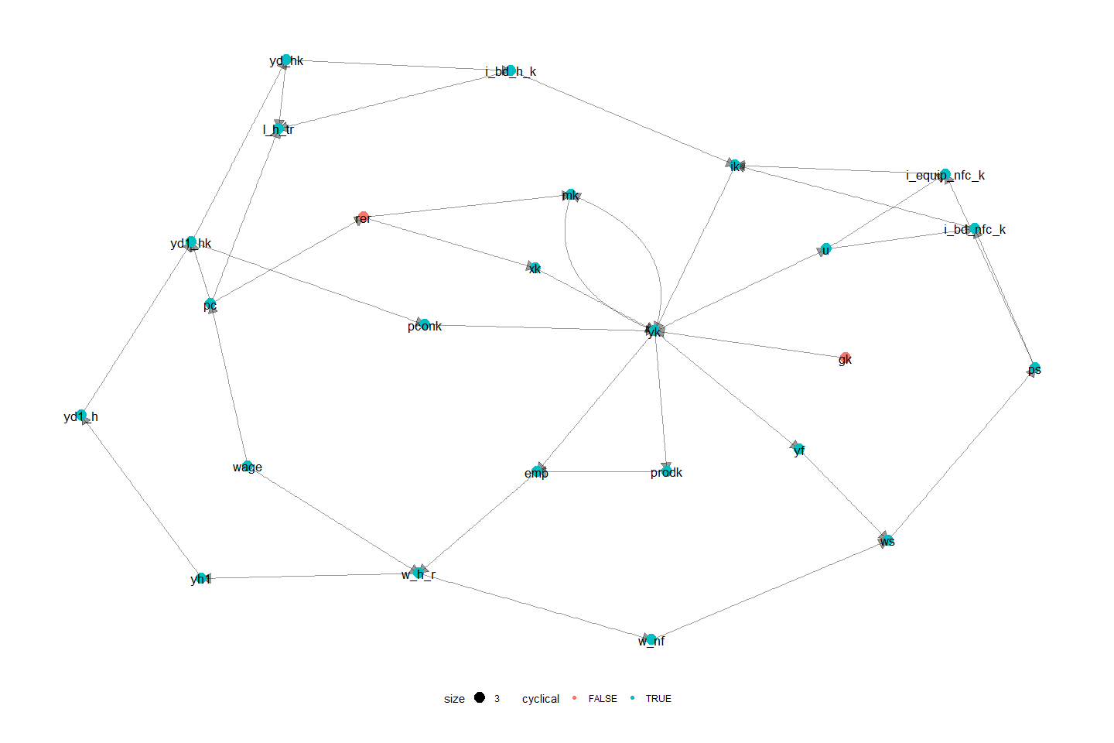

## Appendix 2: Sensitivity analysis

To make sure that the results obtained in this paper, as well as the conclusion derived from these results are not affected by small changes of crucial coefficients in the model. We perform a sensitivity test of the most influential parameters in the shocks.

Figure A2‑1: Sensitivity of the relationship between the maximum level of income insurance, and the average level of income insurance.

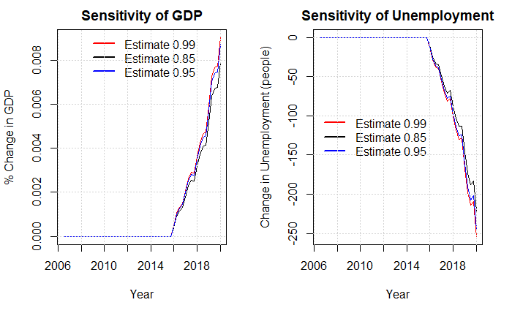

In the plot above we look at the estimate going into the equation of the average income insurance when performing the shock in scenario 1. We know that the estimate should be between 0.85 and 1 as the fraction of receivers of the maximum level of income insurance is 0.85. And no more than 100% can receive the maximum level.

Figure A2‑2: Sensitivity of the minimum wage-gap limit

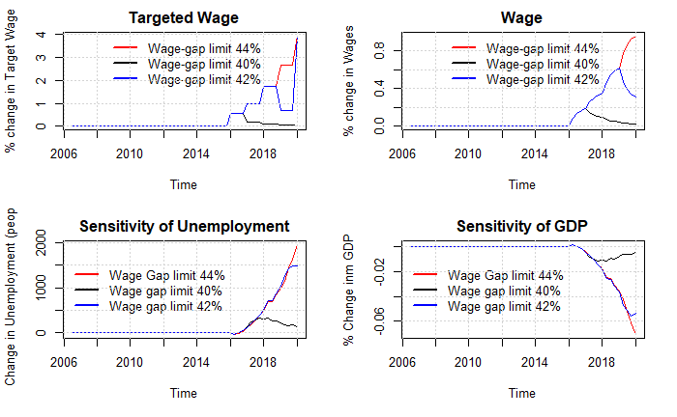

In the plot above we test a central parameter used for the results of this paper being the estimate used for the wage channel setting the limit that the worker unions will allow for the wage gap. As we don’t observe this limit in the data it is hard to find any evidence that backs up the value of this parameter. We use the empirical results from (Fredriksson & Söderström, 2020) setting the minimum wage gap allowed to be 42% of the wage. In the plot below, we see the effects of changing this limit to 40% or 44%.

Figure A1‑3: Relaxing assumptions in the productivity channel

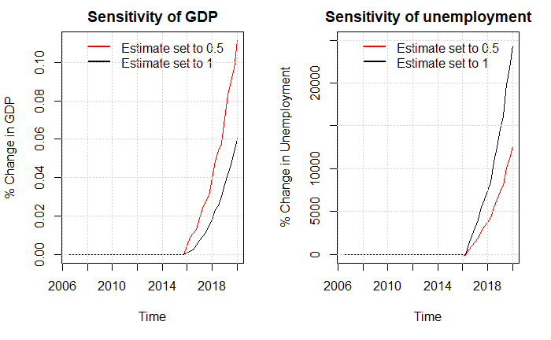

In the figure above we focus on the productivity channel, we mostly exclude this channel due to the lack of empirical justification as well as the radical results found in scenario 5. In an attempt to make the shock more realistic we relax the assumption that firms from one period to another can adjust employment to match the demand, we now obtain much lower effects on unemployment. But the overall match between simulated data and real data is very weak, making these results less trustworthy.

Figure A2‑4: Including the productivity channel in scenario 6.

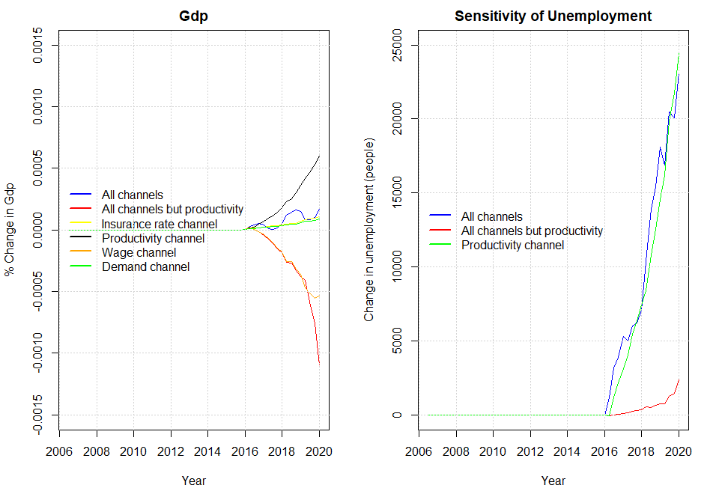

As argued above we exclude the productivity channel in scenario 6 when letting the channels interact. As we mainly use the results from scenario 6 to evaluate the decision to suppress the state regulation percentage, we now show the effects of not excluding the productivity channel when finding these results. As mentioned in the paper, we now obtain an elasticity of 3 of the macroeconomic effects.

Figure A2‑5: Removing autonomous consumption, restricting estimate of the profit-share to -0.1 from -0.45.

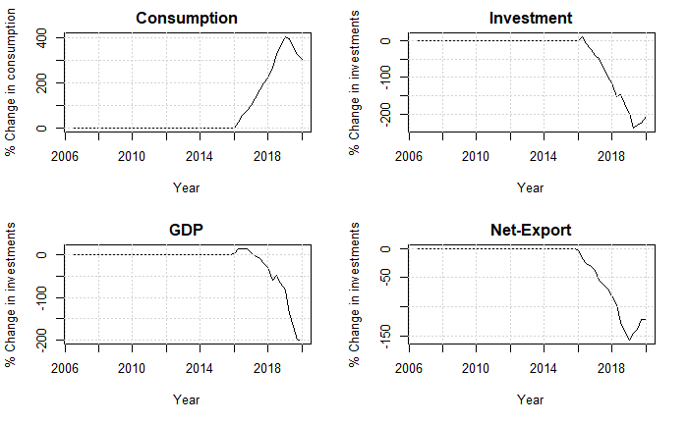

Figure A2-6: Removing autonomous consumption, restricting estimate of the profit-share to 0.1 from 0.45, and setting estimate of real exchange rate on exports to - 0.1 instead of -0.24

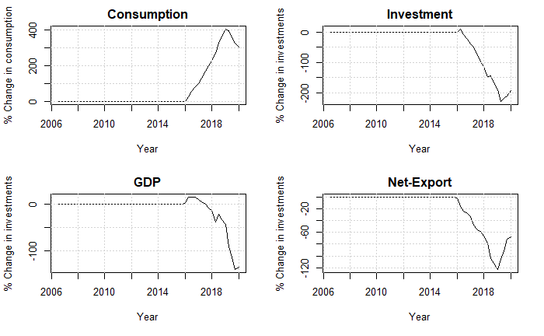

In the two plots above we test the sensitivity of Denmark being categorized as profit led. We do so by changing important coefficients in the investment, consumption and export function. In the last plot we see that the increase in consumption is actually larger than the decrease of investments and net-exports, but as the real government spending is falling (due to nominal government spending being exogenous in the mode) GDP is still decreasing. Here we conclude that really large changes are necessary to define Denmark as wage led.

## Appendix 3: List of equations of the full model and related symbols

As done in the paper, capital letters denote nominal variables and lower-case letters denote real variables.

|  |  |
| --- | --- |
| **Non-Financial Corporations** |  |
|  | (A. 1) |
|  | (A. 2) |
|  | (A. 3) |
|  | (A. 4) |
|  | (A. 5) |
|  | (A. 6) |
|  | (A. 7) |
|  | (A. 8) |
|  | (A. 9) |
|  | (A. 10) |
|  | (A. 11) |
|  | (A. 12) |
|  | (A. 13) |
|  | (A. 14) |
|  | (A. 15) |
|  | (A. 16) |
|  | (A. 17) |
|  | (A. 18) |
|  | (A. 19) |
|  | (A. 20) |
|  | (A. 21) |
|  | (A. 22) |
|  | (A. 23) |
|  | (A. 24) |
|  | (A. 25) |
|  | (A. 26) |
|  | (A. 27) |
|  | (A. 28) |
|  | (A. 29) |
|  | (A. 30) |
|  | (A. 31) |
|  | (A. 32) |
|  | (A. 33) |
|  | (A. 34) |
|  | (A. 35) |
|  | (A. 36) |
|  | (A. 37) |
|  |  |
| **Households** |  |
|  | (A. 38) |
|  | (A. 39) |
|  | (A. 40) |
|  | (A. 41) |
|  | (A. 42) |
|  | (A. 43) |
|  | (A. 44) |
|  | (A. 45) |
|  | (A. 46) |
|  | (A. 47) |
|  |  |
|  | (A. 48) |
|  | (A. 49) |
|  | (A. 50) |
|  | (A. 51) |
|  | (A. 52) |
|  | (A. 53) |
|  | (A. 54) |
|  | (A. 55) |
|  | (A. 56) |
|  | (A. 57) |
|  | (A. 58) |
|  | (A. 59) |
|  | (A. 60) |
|  | (A. 61) |
|  | (A. 62) |
|  | (A. 63) |
|  | (A. 65) |
|  | (A. 66) |
|  | (A. 67) |
|  | (A. 68) |
|  | (A. 69) |
|  | (A. 70) |
|  | (A. 71) |
|  | (A. 72) |
|  | (A. 73) |
|  | (A. 74) |
|  | (A. 75) |
|  | (A. 76) |
|  | (A. 77) |
|  | (A. 78) |
|  | (A. 79) |
|  |  |
| **Financial Sector** |  |
|  | (A. 80) |
|  | (A. 81) |
|  | (A. 82) |
|  | (A. 83) |
|  | (A. 84) |
|  | (A. 85) |
|  | (A. 86) |
|  | (A. 87) |
|  | (A. 88) |
|  | (A. 89) |
|  | (A. 90) |
|  | (A. 91) |
|  | (A. 92) |
|  | (A. 93) |
|  | (A. 94) |
|  | (A. 95) |
|  | (A. 96) |
|  | (A. 97) |
|  | (A. 98) |
|  | (A. 99) |
|  | (A. 100) |
|  | (A. 101) |
|  | (A. 102) |
|  | (A. 103) |
|  |  |
| **Government** |  |
|  | (A. 104) |
|  | (A. 105) |
|  | (A. 106) |
|  | (A. 107) |
|  | (A. 108) |
|  | (A. 109) |
|  | (A. 110) |
|  | (A. 111) |
|  | (A. 112) |
|  | (A. 113) |
|  | (A. 114) |
|  | (A. 115) |
|  | (A. 116) |
|  |  |
| **Rest of the world** |  |
|  | (A. 117) |
|  | (A. 118) |
|  | (A. 119) |
|  | (A. 120) |
|  | (A. 121) |
|  | (A. 122) |
|  | (A. 123) |
|  | (A. 124) |
|  | (A. 125) |
|  | (A. 126) |
|  | (A. 127) |
|  | (A. 128) |
|  | (A. 129) |
|  | (A. 130) |
|  | (A. 131) |
|  | (A. 132) |
|  |  |
| **Labour market** |  |
|  | (A. 133) |
|  | (A. 134) |
|  | (A. 135) |
|  | (A. 136) |
|  | (A. 137) |
|  | (A. 138) |
|  | (A. 139) |
|  | (A. 140) |
|  | (A. 141) |
|  | (A. 142) |
|  | (A. 143) |
|  | (A. 144) |
|  | (A. 145a) |
|  | (A. 146) |
|  | (A. 147) |
|  | (A. 148) |
| **Wage channel equations:** |  |
|  | (A. 145b) |
|  |  |
| **Insurance rate channel equations:** |  |
|  | (A. 149) |
| **Labor-force channel equations:** |  |
|  | (A. 150) |
|  | (A. 151) |
| **Productivity channel equations:** |  |
|  | (A. 152) |

**Symbols**:

N = non-financial corporations, F = financial corporations, G = government, H = Households, W = Rest of the World

|  |  |
| --- | --- |
| Notation | Description |
|  | Nominal GDP |
|  | Nominal Private Consumption |
|  | Nominal Gross fixed capital formation |
|  | Noninal Exports of goods and services |
|  | Nominal Imports of goods and services |
|  | GDP deflator |
|  | Real GDP |
|  | Real Private Consumption |
|  | Real Gross fixed capital formation |
|  | Real Exports of goods and services |
|  | Real Imports of goods and services |
|  | Nonfinancial corporations Nominal Investment in Buildings and Dwellings |
|  | Financial corporations Nominal Investment in Buildings and Dwellings |
|  | Households Nominal Investment in Buildings and Dwellings |
|  | Government Nominal Investment in Buildings and Dwellings |
|  | Nonfinancial corporations Nominal Investment in Equipment |
|  | Financial corporations Nominal Investment in Equipment |
|  | Households Nominal Investment in Equipment |
|  | Government Nominal Investment in Equipment |
|  | Price deflator on consumption |
|  | Wage bill paid by firms |
|  | Wage bill received by households |
|  | Wage bill received by the rest of the world |
|  | Total Employment |
|  | Employment hired to the households |
|  | Employment hired to the rest of the world |
|  | Unemployment |
|  | Rate of unemployment |
|  | Labour force |
|  | Population |
|  | Retired people |
|  | Wage rate |
|  | Disposable income |
|  | Disposable income of profit |
|  | Disposable income on wages/transfers |
|  | Change in pension entitlements |
|  | Benefits received by the households |
|  | Benefits received by the households subtracted the amount paid in income insurance |
|  | Benefits received by the households in the form of income insurance |
|  | Savings |
|  | Aggregate gross operating surplus |
|  | Sectoral gross operating surpluses |
|  | Net interest income on interest bearing assets |
|  | Net interest income on insurance |
|  | Net dividends |
|  | Net indirect taxes |
|  | Income taxes |
|  | Social contributions |
|  | Social benefits |
|  | Other current transfers |
|  | GDP at factor costs |
|  | Profit share |
|  | Labour productivity |
|  | Capacity utilization |
|  | Tobin’s q |
|  | Real exchange rate |
|  | Nominal exchange rate |
|  | Stock of buildings and dwellings |
|  | Stock of capital of equipment |
|  | Net lending |
|  | Current account balance |
|  | Net acquisitions of non-produced non-financial assets |
|  | Capital transfers |
|  | Stock of Equities |
|  | Transaction of equities |
|  | Capital gains on equities |
|  | Nonfinancial corporations’ demand for equities (flow) |
|  | Nonfinancial corporations’ supply of equities (flow) |
|  | Financial corporations’ demand for equities (flow) |
|  | Financial corporations’ supply of equities (flow) |
|  | Households demand for equities issued by nonfinancial corporations |
|  | Households demand for equities issued by financial corporations |
|  | Households demand for equities issued by the rest of the world |
|  | Stock of interest-bearing assets |
|  | Transaction of interest-bearing assets |
|  | Capital gains on interest-bearing assets |
|  | Stock of loans |
|  | Transaction of loans |
|  | Capital gains on loans |
|  | Stock of securities |
|  | Transaction of securities |
|  | Capital gains on securities |
|  | Domestic securities issued by Financial corporations |
|  | Domestic securities held by the rest of the world |
|  | Stock of insurance technical reserves |
|  | Transaction of insurances |
|  | Capital gains on insurances |
|  | Financial net wealth |
|  | Net wealth |
|  | Maximum level of income insurance |
|  | Rate adjustment percentage |
|  | State regulation percentage |
|  | Adjustment percentage |
|  | Compensation rate |
|  | Average amount of income insurance received per person in the IS-program. |
|  | The rate of people being member of the IS-program. |
|  | Inflation |

**Parameters**

|  |  |
| --- | --- |
|  | Net indirect tax rate |
|  | Income tax rate levied Households |
|  | Income tax rate levied on nonfinancial corporations |
|  | Income tax rate levied on financial corporations |
|  | Price deflator of building and dwellings |
|  | Price deflator of Equipment |
|  | Price deflator of imports |
|  | Price deflator of exports |
|  | Price deflator of public consumption |
|  | International price index |
|  | Depreciation rates of the capital stock |
|  | Interest rate on interest-bearing assets |
|  | Interest rate on securities |
|  | Interest rate on loans |
|  | Interest rate on insurance technical reserves |
|  | Dividend distribution rate |
|  | Households share of equities issued by nonfinancial corporations |
|  | Households share of equities issued by financial corporations |
|  | Minimum wage-gap allowed by the workers unions. |

## Appendix 4: estimation of behavioral equations

### Baseline:

Figure A4‑1: Households Consumption

Figure A4‑7a: Households investments in buildings and dwellings

Figure A4‑2b: Summary of regression above

Figure A4‑8: Benefits received by Households subtracted with the amount paid in income insurance

Figure A4‑9: Households demand for loans

Figure A4‑10: Households demand for equities

Figure A4‑11: Households contribution to the pension system

Figure A4‑12: Exports

Figure A4‑13: Imports

Figure A4‑14a: Non-financial Corporations’ investment in buildings and dwellings

Figure A4‑8b: Summary statistics for regression above

Figure A4‑9a: Non-financial Corporations’ investment in equipment

Figure A4‑9b: Summary statistics for regression above

Figure A4‑10a: Prices

Figure A4‑10b: Summary statistics for regression above

Figure A4‑11: Wages

### Regressions for Scenarios

Figure A4‑12: productivity of workers

Figure A4‑12: Labor force

Figure A4‑13: Insurance rate

1. Benefits received if you do not meet the requirements of income insurance program.
2. Only the first three parts will be presented, as the re-earning model only concern changes towards the rules for re-earning the right to income insurance, thereby not looking at changes to the level of income insurance.
3. As the ministry of finance calculates the maximum level of income insurance once a year, we estimate it for the first quarter hereafter keeping it fixed.
4. There does not exist much international evidence for this channel, as in many countries it is required to be part of the income insurance program.
5. Data used for the insurance rate is obtained from ADAMS databank, and as the data is only available till 2018, we are only able to estimate the equation till 2017 quarter 4. Doing this, we find a positive long-run relationship between the compensation rate and the insurance rate but only at a 10% significance-level.

  
6. In the model we the wage gap estimate a relationship between income insurance and wages to 42% of the wage, thereby, we estimate a relationship between income insurance and wages close to the one found by Fredriksson & Söderström (2020) showing an elasticity of 0.2-0.3 between the replacement rate and wages.
7. The investment of firms also depend on the profit share, which is very likely to be affected negatively by an increase in level of unemployment benefits.
8. We do not see this as a problem, as we are mostly interested in the effects on unemployment.
9. This also supports the arguments, that participation in the labour force is explained by factors not included in this model, like norms, wages relative to other workers, consumption levels, and the standard of living.
10. To keep it simple, we assume that unemployment benefits are paid by the Government. This is of course a simplification, since the reality is way more complex, where private unemployment insurance companies receive contributions from households and pay out unemployment benefits to unemployed households. This means, that the results regarding the effect on the public balance should be interpreted with a little cautions.
11. One possible critic of this method is that the effects from the income insurance model and the model built in this paper will not interact. We don’t see this affecting the overall results, as it will have no effect on the most dominant channel being the wage channel.
12. Evaluated in 2025, so that the full effects have been carried through.
13. As the participation rate is fixed the fall in employment will directly result in an increase in unemployment of the same amount.
14. As they look at a micro foundation they use the unemployment duration of one person, we will use the amount of unemployed in the economy.
15. As this is the estimated value for 2016, where the suppressing of the state regulation percentage started.
16. We use the value of 2016, as this is the year the suppressing of the state regulation percentage started.